Survey Exercise

AN 3571-Professor Spencer-Wood

Marcus Dennehy

Natural Resource Maps

|  | Topography | Farm Land | Soils | Vegetation | Land Use |
| --- | --- | --- | --- | --- | --- |
| Square 1 (Northwest) | Low elevation. Formation of low glacial paths allows the river that flows west to east towards Pride lake. | A couple of agricultural developments at the northernmost tip of the square. | Diverse range of soils, mostly loamy soil on the northern side but southern consists of sandy soil with well drained hills. | A considerable concentration of hardwood and lowerbrush is found within the recreational reserves. Some concentration of pine is found within the southern borders of this square. | Mostly underdeveloped and majority recreational. |
| Square 2 (North East) | Mid to low elevation, the river flows into vast glacial carving (Pride lake). | No farmland present. | Central to western side consists of the same level elevation of poorly drained loamy soil. Eastern side is glacial drainage, showing geological proof of the river's direction, from west to east. | The eastern side is more vegetated, with concentrations of oak, hickory and hardwood found in the central and southern parts of the square. However, there is agricultural cultivation happening in the north west of the square. | Majority of the square is recreational swamp/woodlands. Other notables being underdeveloped land and agricultural use. |
| Square 3/3.5  Southwest, southeast. | High elevation exceeding 1000 ft. Hilly terrain extending from the lower west to lower east side of the reservation.  Rest of the square is inhabited by pastureland at the very south. | Pastures present in the central south region. | Well drained, gently rolling hills, loamy soil. Prime estate for agriculture. | Vegetation in this square is sparse compared to the northern squares. Grass mostly inhabits this area with only a couple dots of oak. | Mostly underdeveloped or agricultural pastures. |

Sample Survey

Cultural Transforms (Question 2)

In the three and a half squares where the survey was taken, a majority of the recreational land had been left undisturbed. Only bits of agriculture had been established there. This provides a great deal of archaeological potential. Although, there is some possibility that the river running into Pride lake could have drifted some artifacts away from their original location. Additionally, there are no local residency within this area, suggesting more prime archaeological potential.

Natural Transforms (Question 3)

Each square provides some details on the unique natural structures. The area where the river flows into the lake has a steep, valley-like pathway from west to east. The elevation in the northeastern square has relatively low elevation, providing a wide marsh. The southern squares however have high elevation. These high elevations have a high density of soil buildup, with the evidence pointing towards the high volume of trees within the area. The southeastern hill is approximately 1000 feet while the southwestern, being parallel, is 950 feet.

Open land (Question 4)

Vast areas of land is left near the north of Pride lake, where a flat plain of marsh lay. This is at the heart of the Pride Lake Reserve, as well as being prime sites of excavation, as this marsh has been undisturbed for generations. Additionally, the flat marshes extend to the northwestern tip of square 1. This could indicate another spot for excavation.

Hunting/Fishing spots (Question 5)

There are numerous spaces for tribes to hunt and fish. One notably being the large hillsides overlooking the river. This would be an advantageous position for hunting. As having a high ground advantage can help spot out large game. The two, high elevation hills have a lookout at the lake, providing key observational information. With the high hills they can create a hunting site, possibly a seasonal hunting site. With the lake also, they have access to fresh water as well as fish. Gathering would also be present here, as nuts grow from the Hickory and Oak trees, not to mention lowland brush having access to berries.

Agricultural Land (Question 6)

There is undeveloped land in the northern and southern reaches of the three squares. There is only one pasture however, located south outside the recreational borders. Agriculture however does not seem apparent in the marshlands as it is flat, the soil has no drainage whatsoever. As the northern side of Pride Lake provides flat land with no drainage, the north end has no flat space, being higher elevation and would have been suitable for hunting.

Woodwork and Shelter (Question 7 and 8)

Lowland brush is available in large quantities on the southeastern border of the reservation. This of course would be good for basket weaving. Saplings also scatter the riverside on the west. There may also be saplings found within the vast grass section located at the edge of the reservation border. More than that was available as oak, pine and hardwood were all available to create shelters. The oak or hardwood may have been used to create canoes on the lake for fishing.

Additionally, the flat marsh lands would be a perfect place to collect reeds for more weaving. Because it is a swamp environment, try to block seeping water by weaving mats on the dirt floor. This would also help with insulation within the shelter.

Clay deposits/Mineral Resources (Question 9 and 10)

There is a high probability that there are clay deposits in at least the northwestern and northeastern squares. Rocks that come into contact with running water manifest clay materials under a stream bed. It is likely that the hunter gatherers used the clay for pots or insulation purposes. However, evidence of stone tools at the moment can be proposed by the apparentness of the stream. Streams carve into rock, therefore, rock and mineral deposits have been exposed over time due to erosion and hunter gatherers molded into stone tools. This is unsure however as the availability of the rock minerals cannot be known until on-field research.

Settlement Patterns (Question 11)

|  | Hunter Gatherer | Agriculturalists |
| --- | --- | --- |
| Possibilities (Pros) | * Hilly landscape * Lots of forest * High, observational elevations * Stream and lake provide fishing spots * Variety of vegetation allows gathering to take place * Trees are suitable for creating shelters * Clay deposits allowed for possible pot making. | * Some grazable land * Streams provide mills * Trees available to create shelter |
| Unlikely (Cons) | * Land turns flat the further north you go. * Unsure of availability of stone in the area | * No drainage of soil * Hilly northern landscape * Lack of a dry, flat landscape * Unlikely hood of reliable soil for agriculture. |

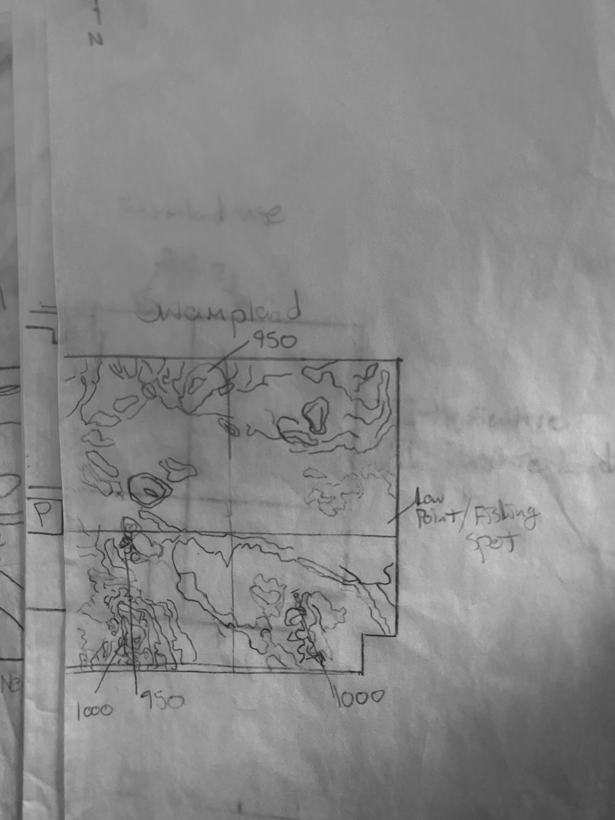

(Swampland)

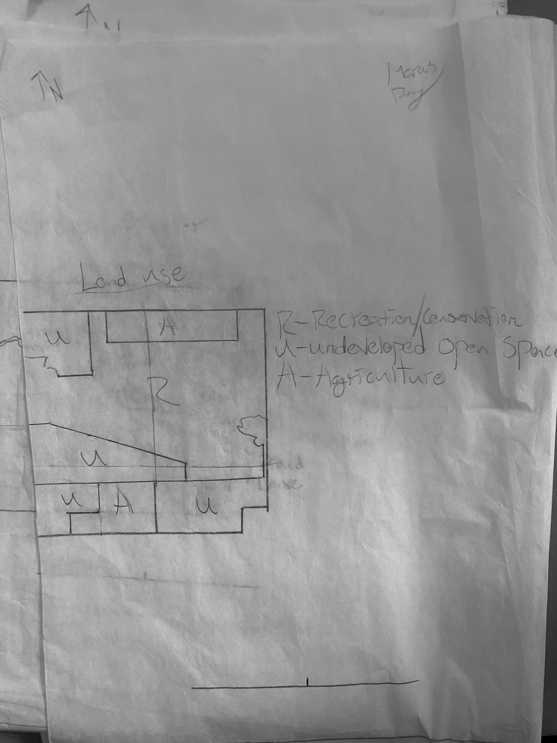

(Land Use)

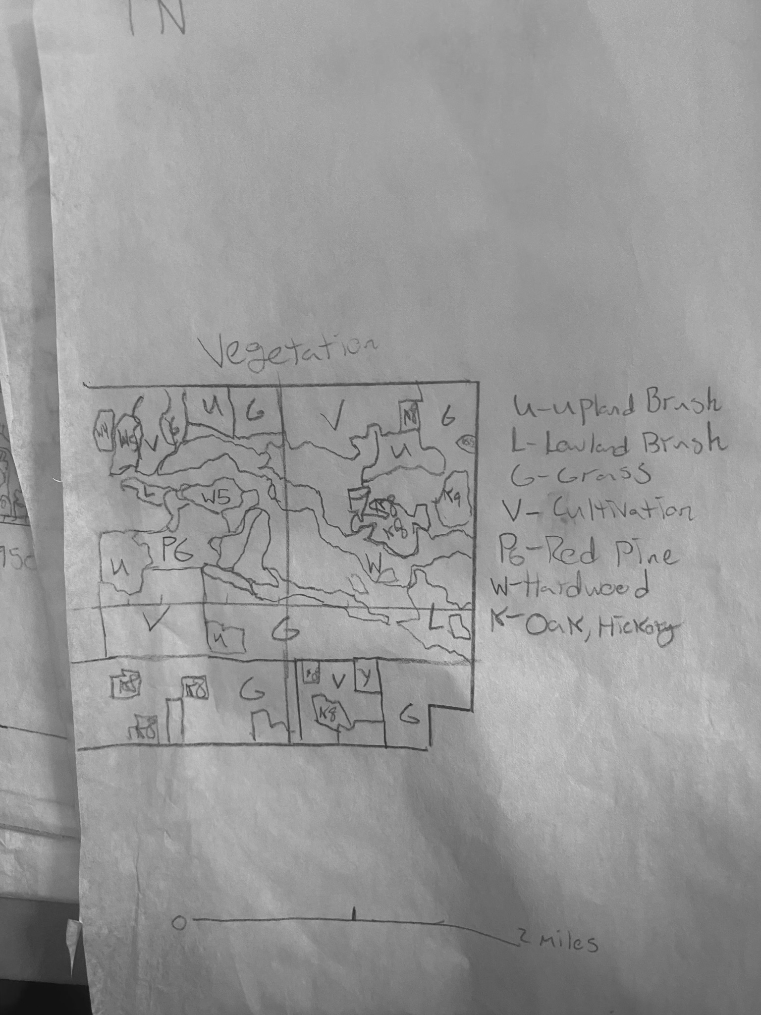

(Vegetation. NOTE; very interesting pattern in square 2 in the center of the square, a strange pattern of oak or hickory is creating a semicircular pattern in the southern edge. Might be a hunch but possible signs of a settlement or religious structure may be hidden there).

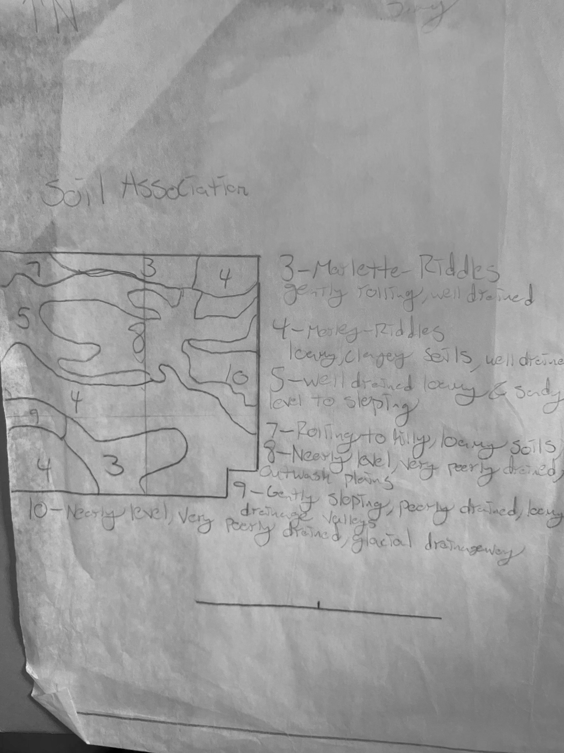

(Soil Association)

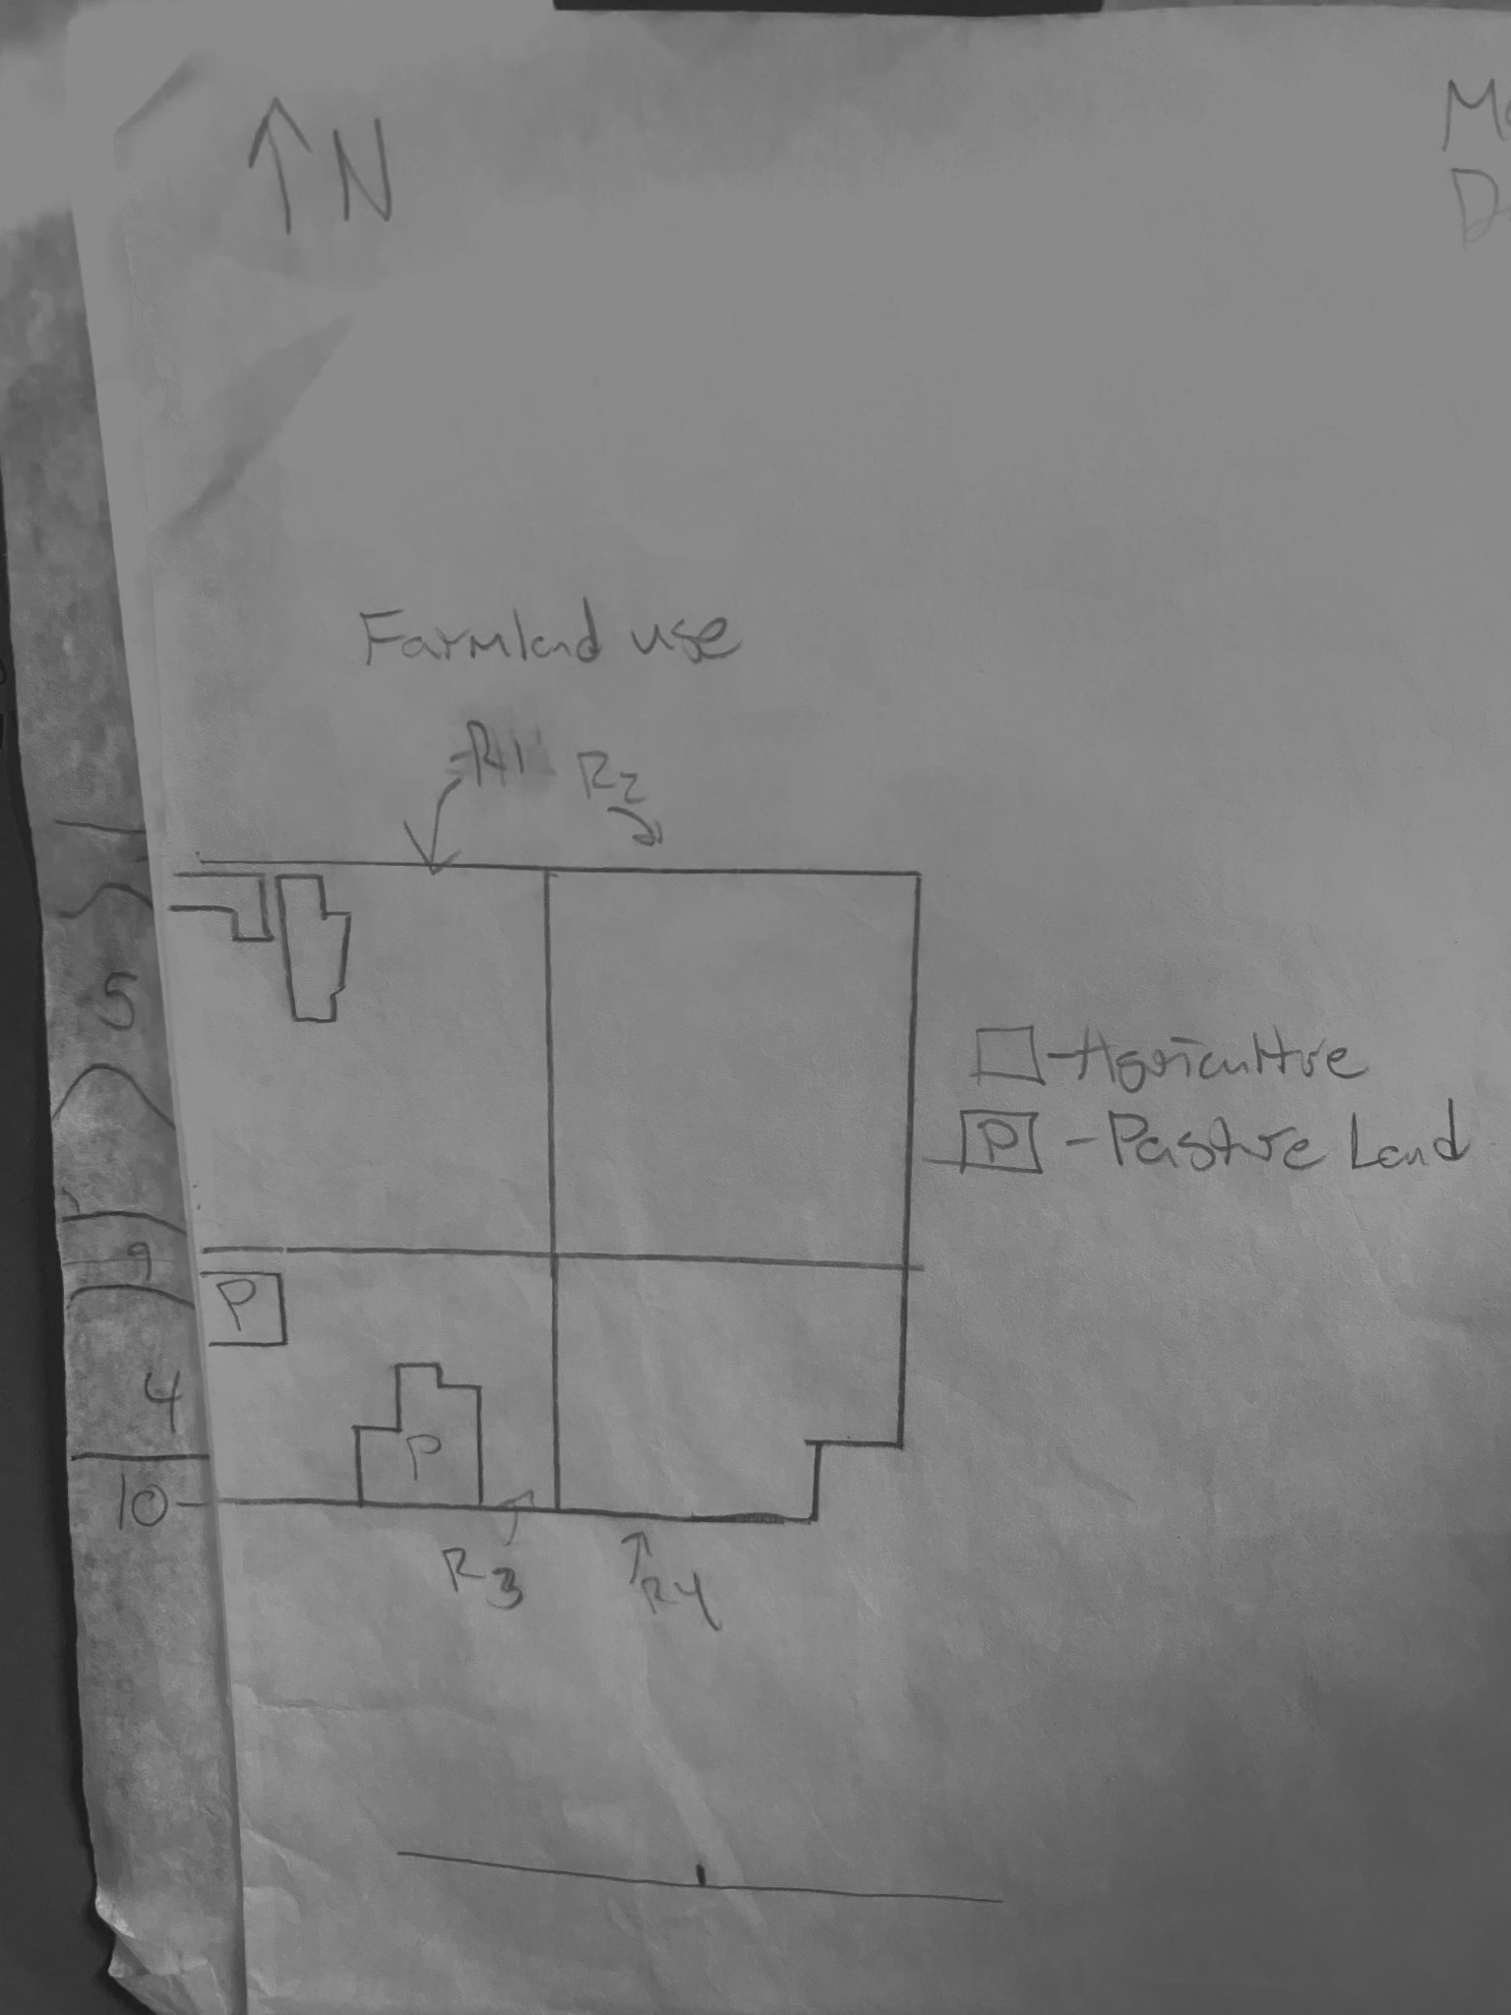

(Farmland Use)